**Step-by-Step Process of Deploying with Maven and Tomcat (Java Code)**

**Launching Instances of Maven and Tomcat:**

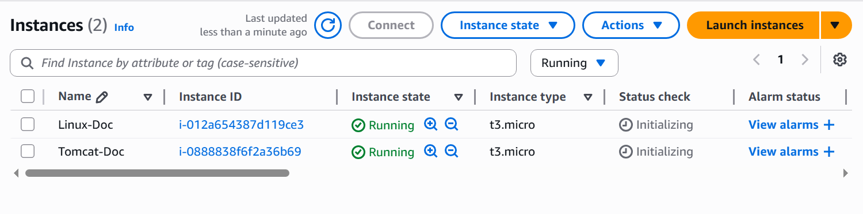

**Connecting Maven:**

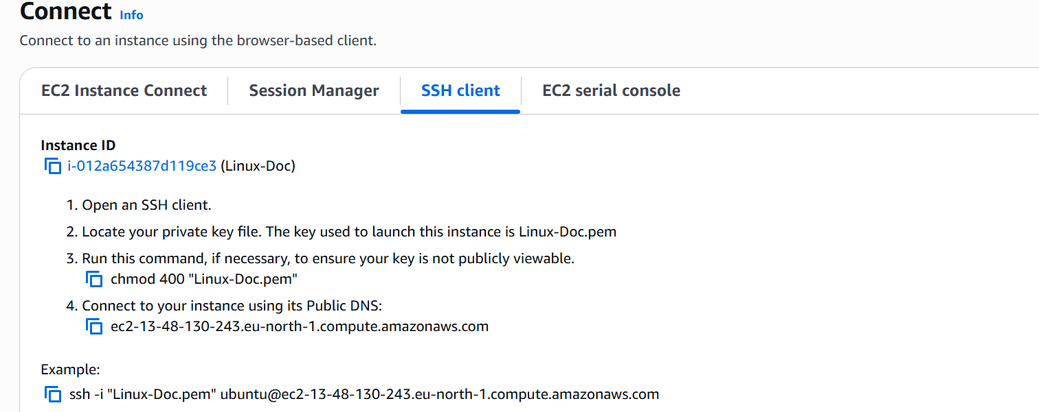

**Updating Server:**



**Installing Java – 17 in Maven Server:**

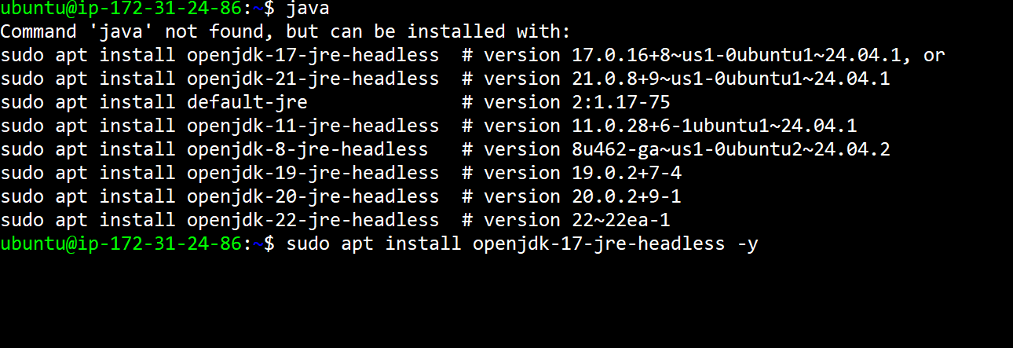

**Installing Maven:**

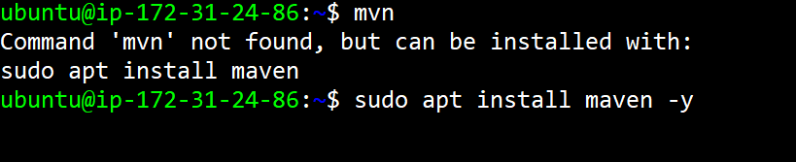

**Cloning Project from GIT:**

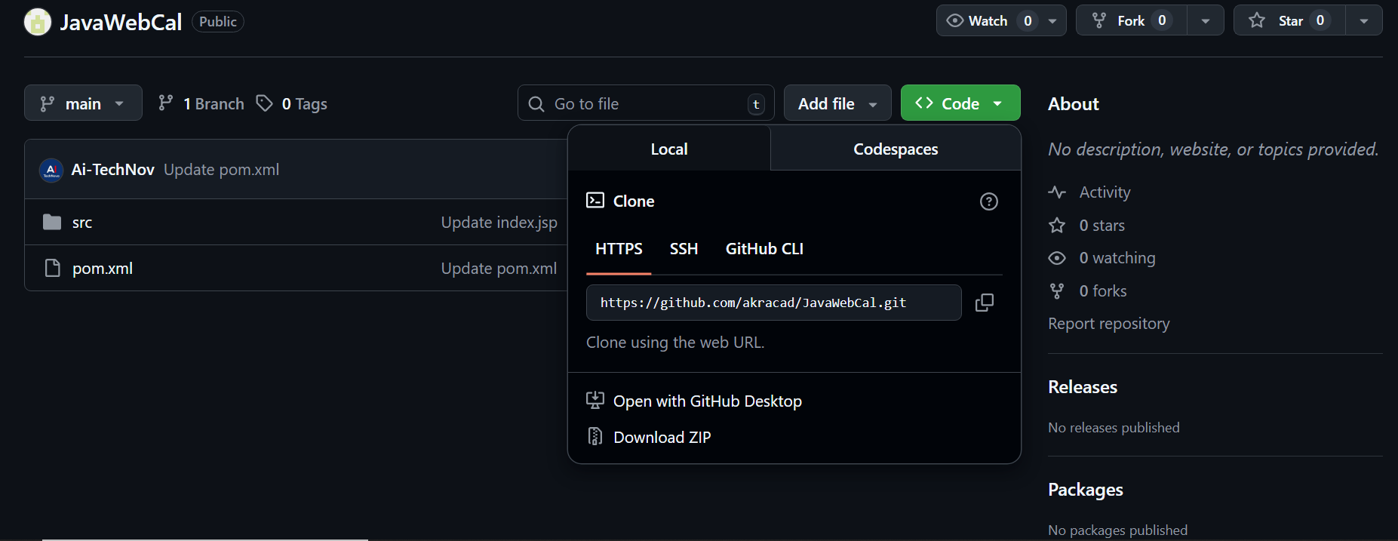

**Cloning into Server by Using git clone:**



**Going to Project Directory:**

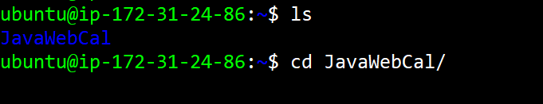

**Validating with mvn validate:**

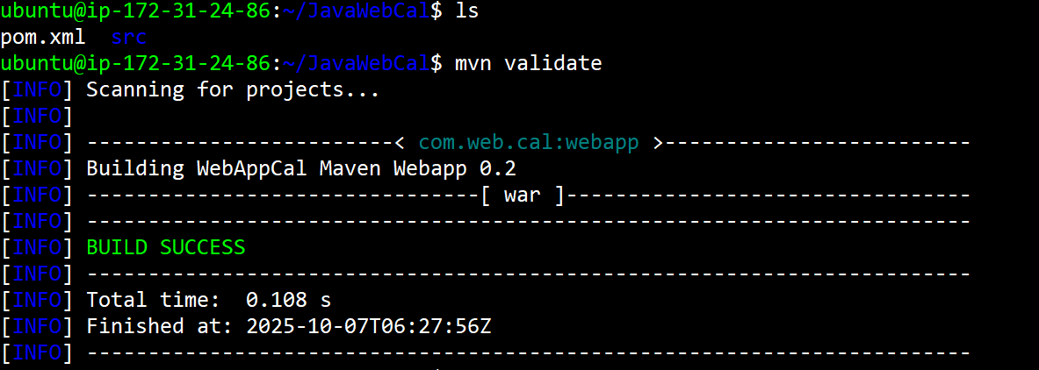

**Editing pom.xml file: “cat >pom.xml” command:**

<project xmlns="[http://maven.apache.org/POM/4.0.0"](http://maven.apache.org/POM/4.0.0%22) xmlns:xsi="[http://www.w3.org/2001/XMLSchema-instance"](http://www.w3.org/2001/XMLSchema-instance%22) xsi:schemaLocation="<http://maven.apache.org/POM/4.0.0>[http://maven.apache.org/maven-v4_0_0.xsd">](http://maven.apache.org/maven-v4_0_0.xsd%22%3E)<modelVersion>4.0.0</modelVersion>  
<groupId>com.web.cal</groupId>  
<artifactId>webapp</artifactId>  
<packaging>war</packaging>  
<version>0.2</version>  
<name>WebAppCal Maven Webapp</name>  
<url>http://maven.apache.org</url>

<properties>  
<project.build.sourceEncoding>UTF-8</project.build.sourceEncoding>  
<maven.compiler.source>1.8</maven.compiler.source>  
<maven.compiler.target>1.8</maven.compiler.target>  
</properties>

<dependencies>  
<dependency>  
<groupId>junit</groupId>  
<artifactId>junit</artifactId>  
<version>4.8.2</version>  
<scope>test</scope>  
</dependency>

<!-- Servlet API -->  
<dependency>  
<groupId>javax.servlet</groupId>  
<artifactId>javax.servlet-api</artifactId>  
<version>3.1.0</version> <!-- Updated to a newer version -->  
<scope>provided</scope> <!-- Servlet API is provided by the container -->  
</dependency>  
</dependencies>

<build>  
<plugins>  
<plugin>  
<groupId>org.apache.maven.plugins</groupId>  
<artifactId>maven-war-plugin</artifactId>  
<version>3.3.2</version> <!-- Updated to a stable recent version -->  
</plugin>  
</plugins>  
</build>

<distributionManagement>  
<repository>  
<id>releases</id>  
<url>[http://binary.ibm.com/nexus/content/repositories/releases</url>](http://binary.ibm.com/nexus/content/repositories/releases%3C/url%3E)</repository>  
</distributionManagement>

</project>

**Cleaning: mvn clean**



**Packaging to generate Artifact: mvn package**



**Generates Target Folder:**

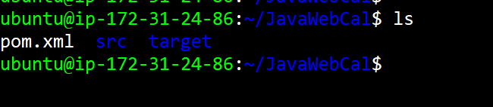

**Connecting With Tomcat Server:**

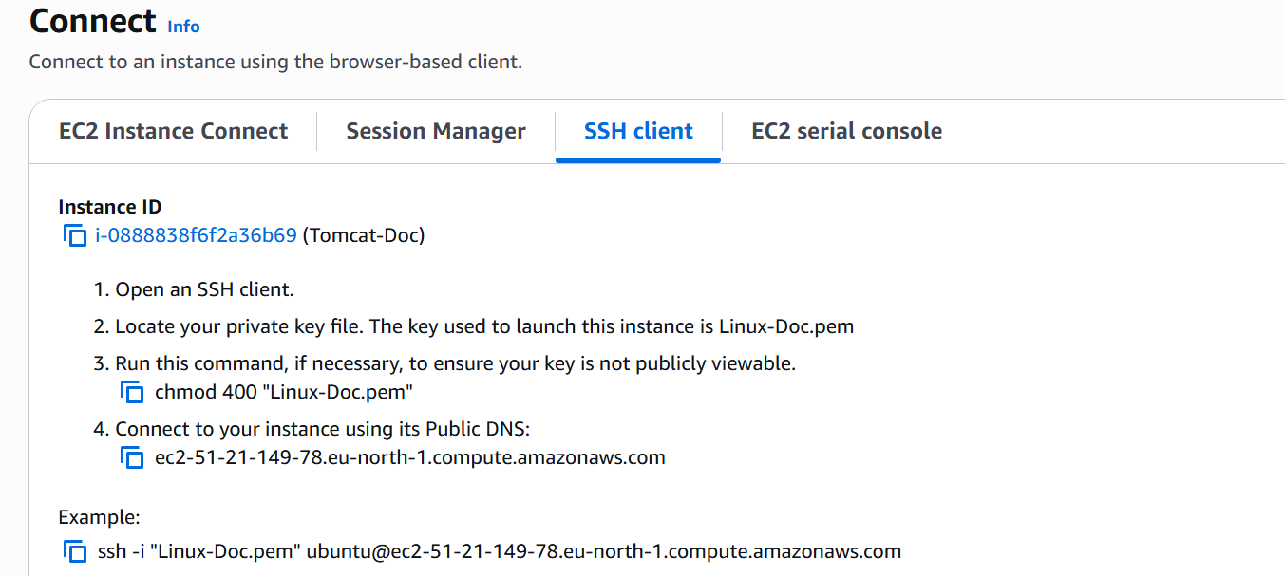

**Updating Tomcat Server:**

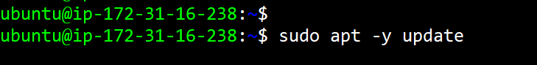

**Installing Java – 17 to Tomcat – Server:**

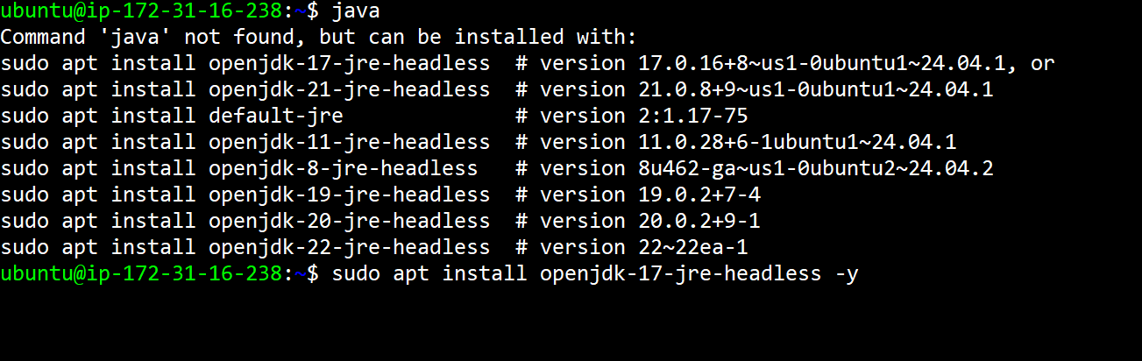

**Installing Tomcat tar file to the server:**

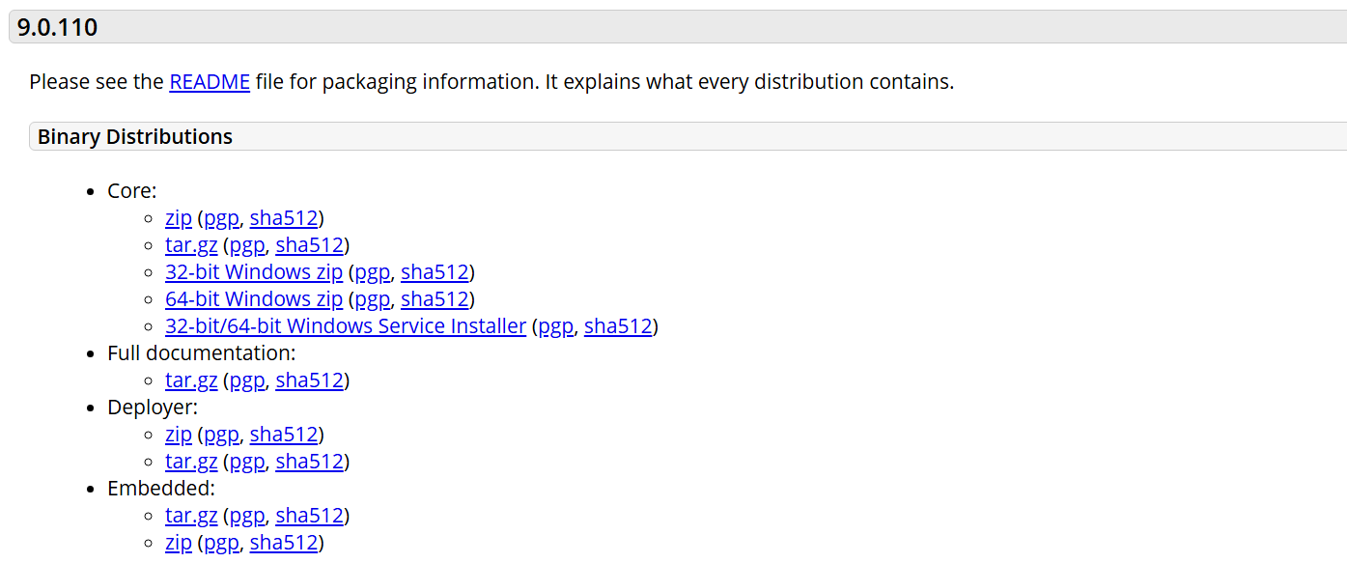

**Untaring Tomcat file which I have Installed:**

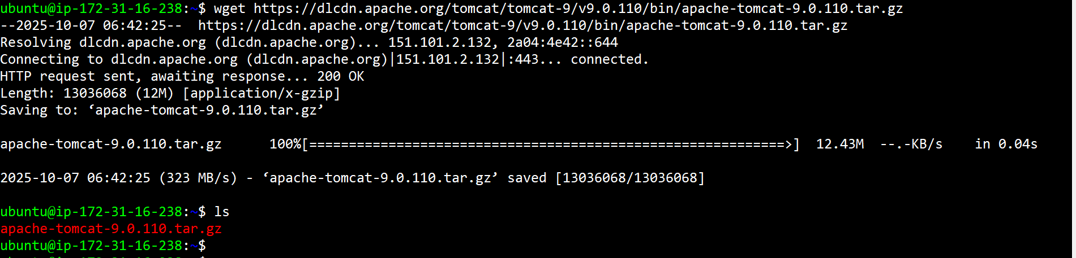

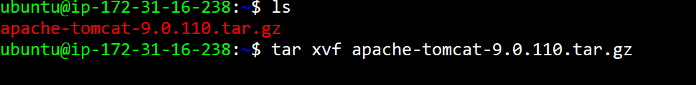



**Folder Structure of Tomcat:**

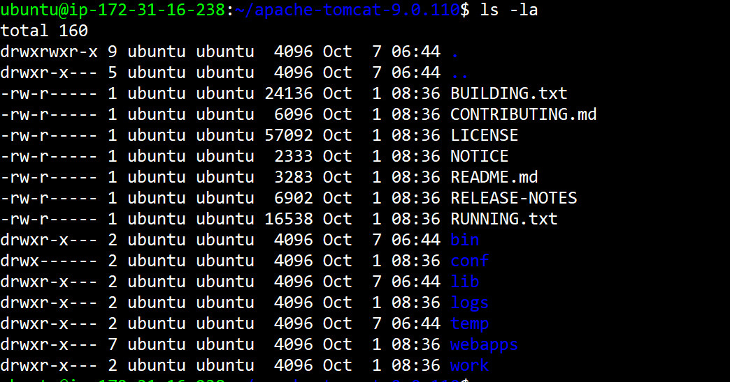

**Now Entering into /bin Directory:**



**Folder Structure of /bin Directory:**

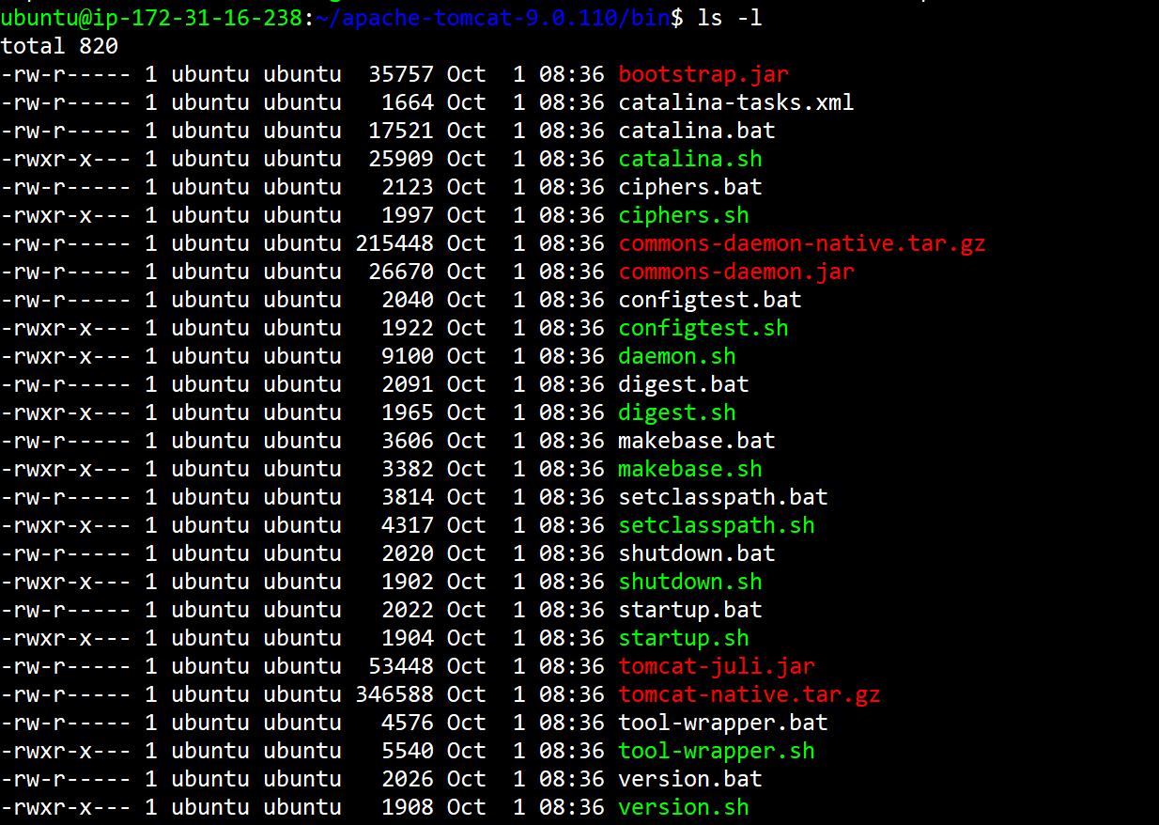

**Now Use ./startup.sh Command to Start the Tomcat:**



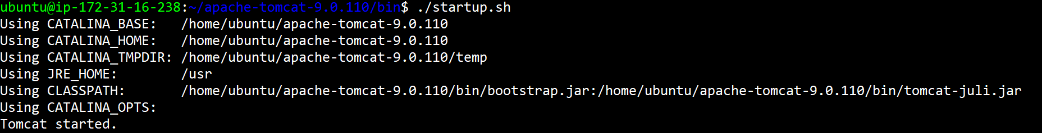

**Now Go Back to Instance Click on Security rules:**

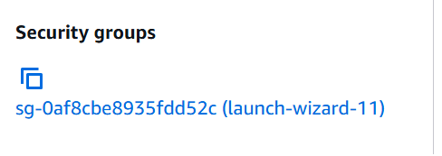

**Now Edit Inbound rules:**

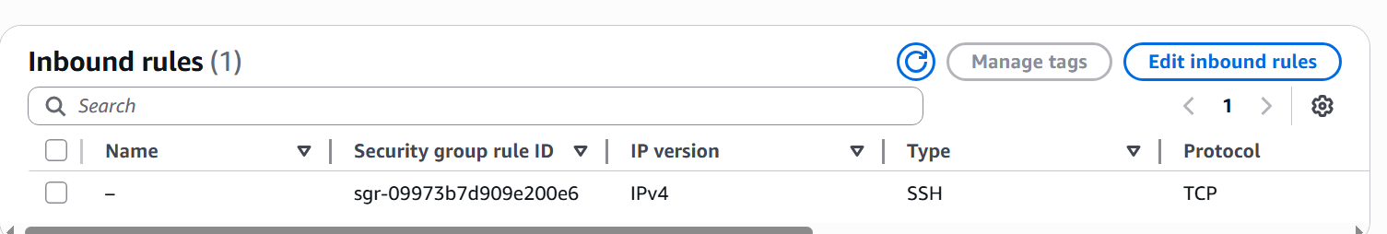

**Now adding port 8080 to rules:**

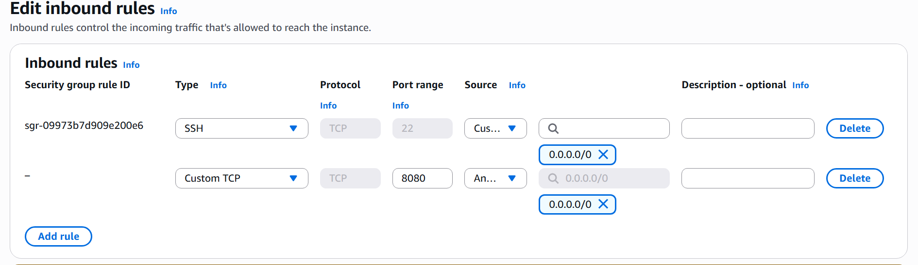

**Copying IP of Tomcat and Paste in Web browser to see tomcat is running or not:**

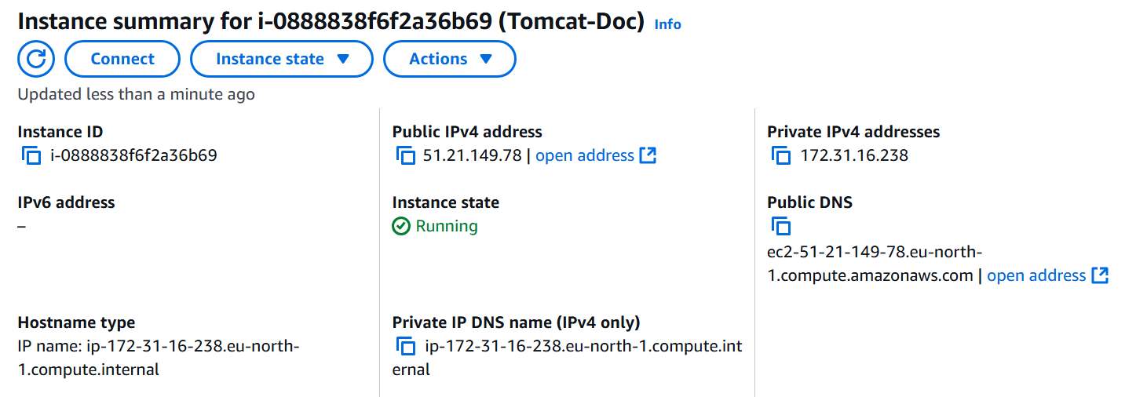

**Finally, Tomcat is Running:**

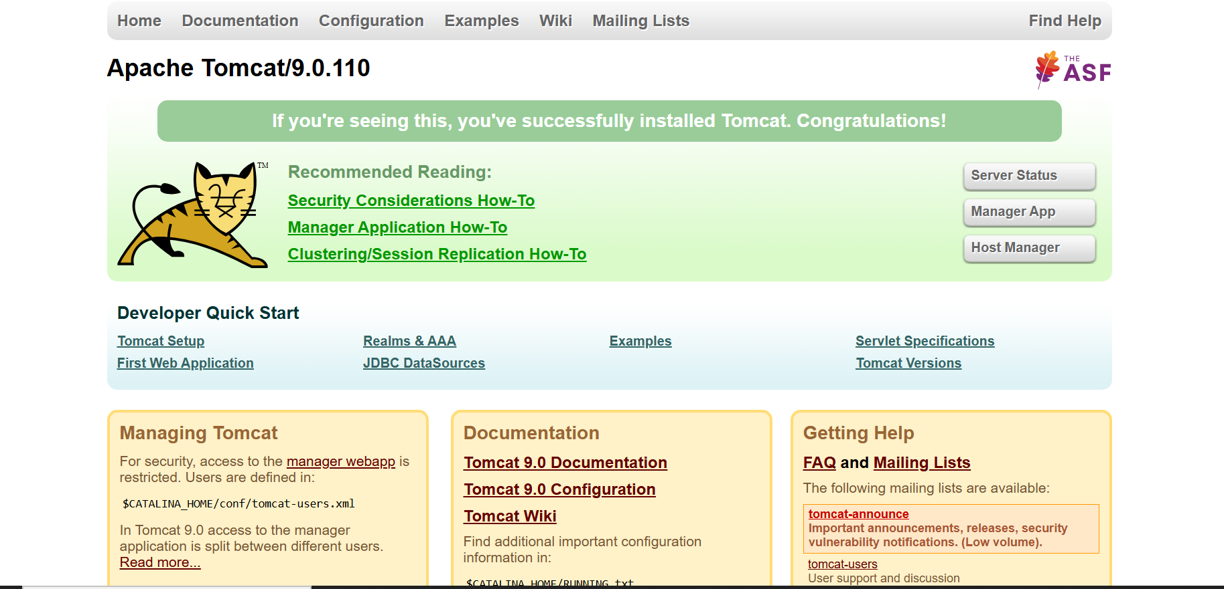

**Coping this From Manager App and Pasting in tomcat-users.xml file:**



**Now Use cd** **.. to go back and enter into /conf Directory:**



**Folder Structure of /conf Directory:**

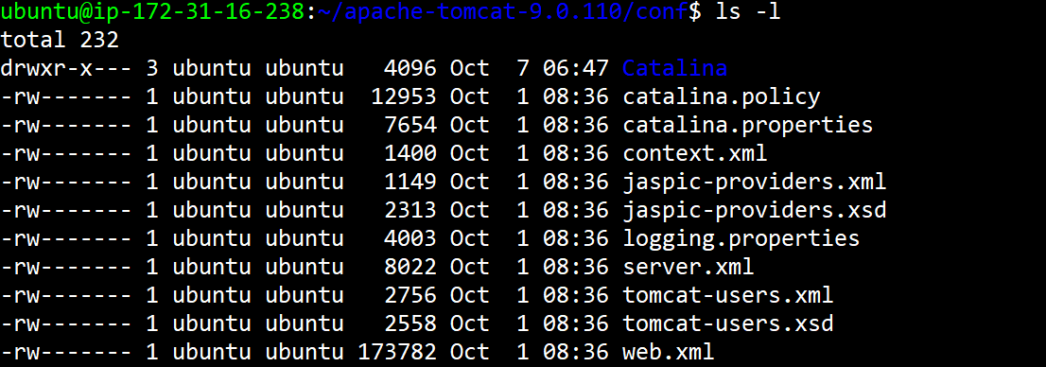

**Now, edit tomcat-users.xml file:**



**Pasting copied data from manager page:** 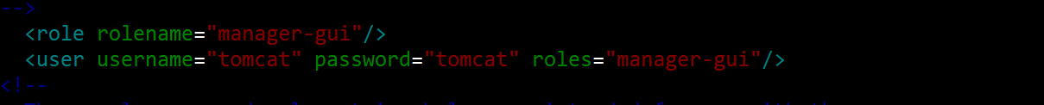

**Now, Entering into /webapps Directory:**



**Folder Structure of /webapps Directory:**

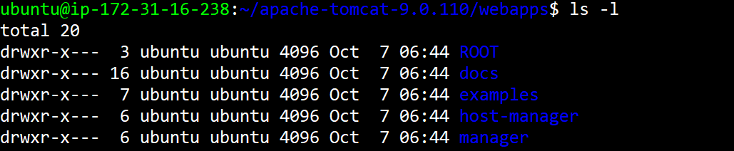

**Enter into /manager Directory:**



**Folder Structure of /manager Directory:**

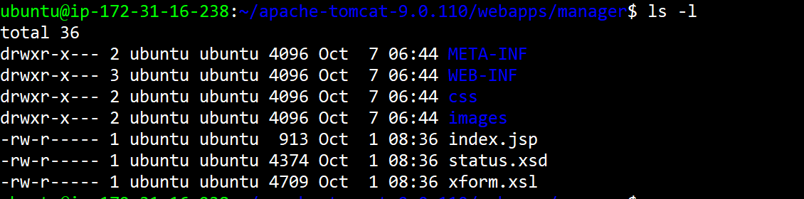

**Enter into /META-INF Directory:**



**Commenting in context.xml file:**

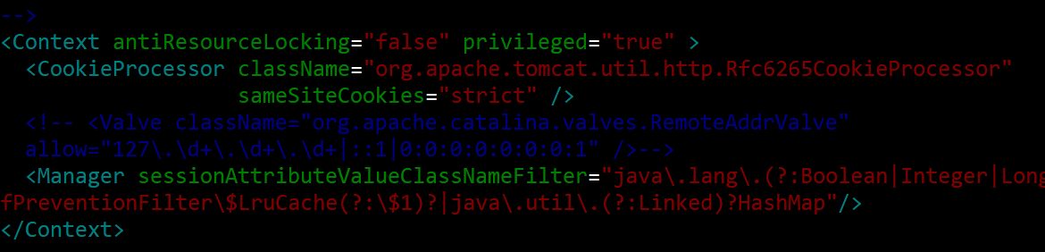

**Now Go back to /webapps directory and enter into /host-manager directory:**



**Folder Structure of /host-manager Directory:**

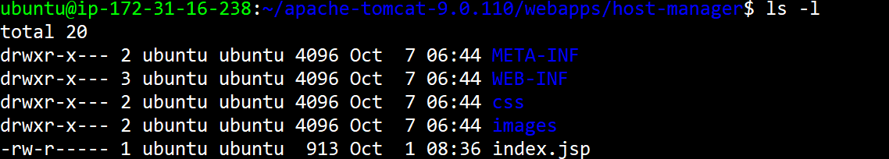

**Enter into /META-INF Directory:**



**Commenting in context.xml file:**

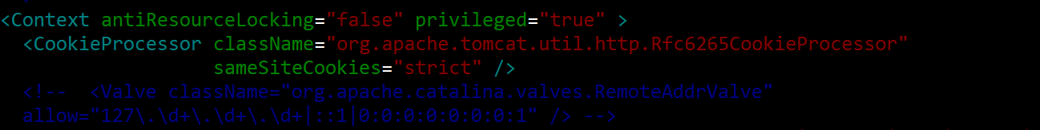

**Now Go back to the Webpage and Once Refresh the Page you will find Sign page of manager:**

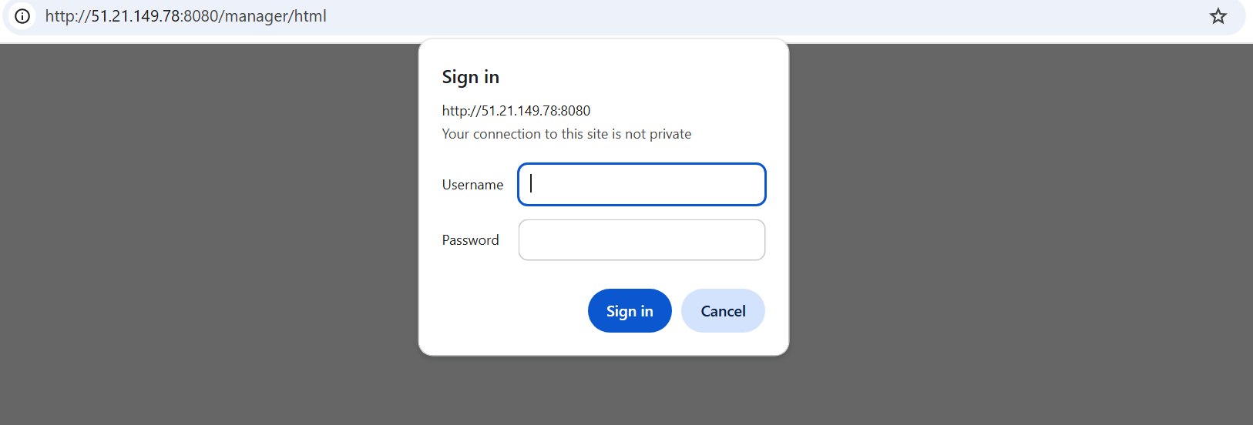

**Now Enter the Credentials which we have given, and It Displays the web page of Tomcat:**

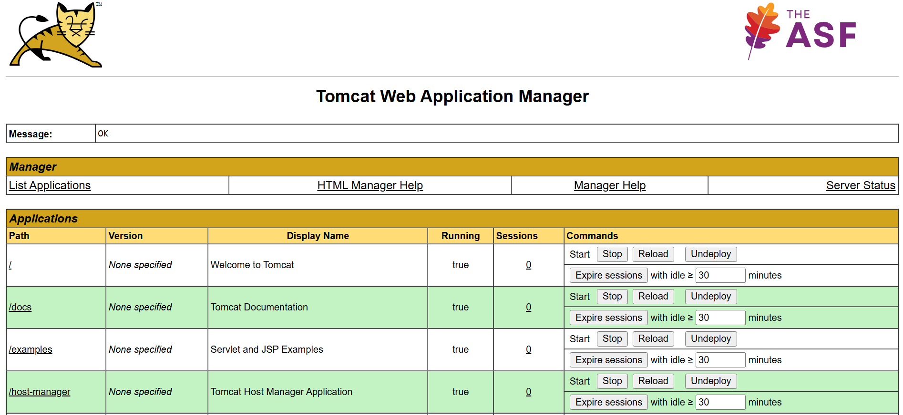

Now, Go back to home use **cd** command

**Now Enter into .ssh/ Directory:**



**Now Generate the ssh keys to connect with Tomcat server:**

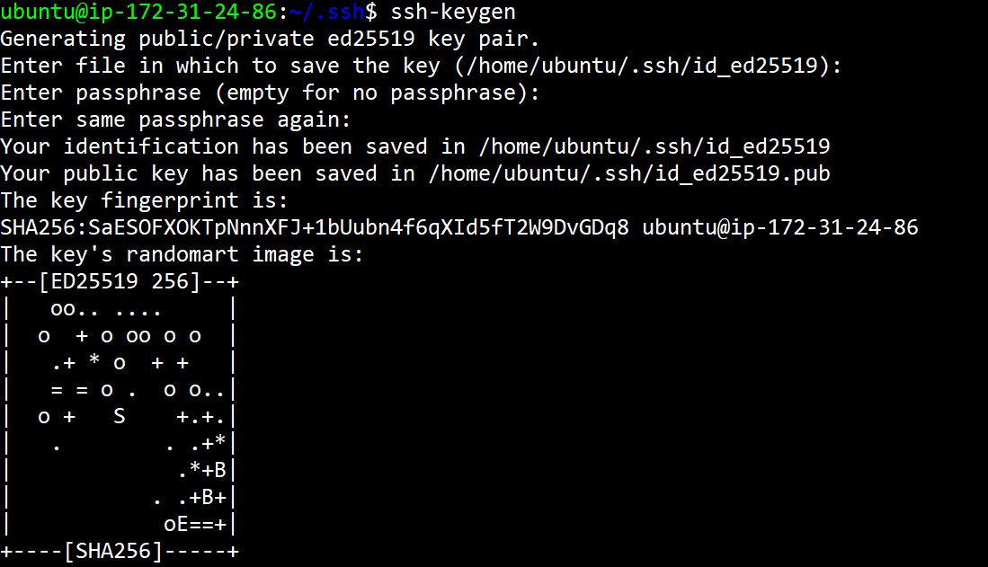

**Check the Keys .pub is created or not:**



**Reading .pub key:**



**Now Copying this key and go to another server of Tomcat and enter .ssh/ Directory:**

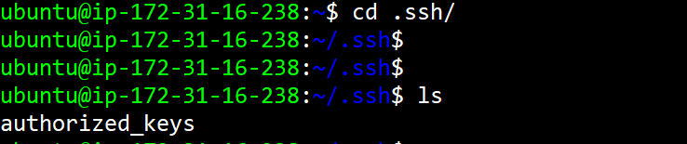

**Edit or paste in authorized_keys file:**



**Pasting the Copied Key in authorized_keys file:**

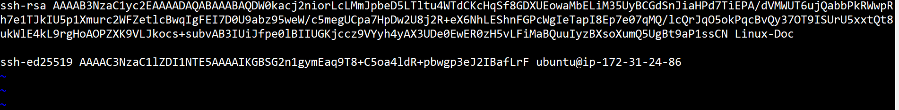

**And Now Go back to Maven server and use this command to transfer .war file to /webapps of Tomcat:**

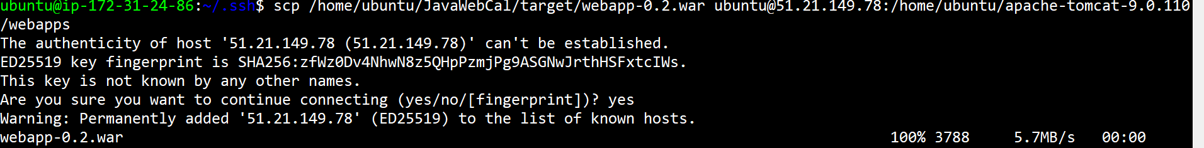

**Check Once if .war file is transferred to /webapps Directory in Tomcat server or not:**



**Now you can see the .war file in manager web page:**

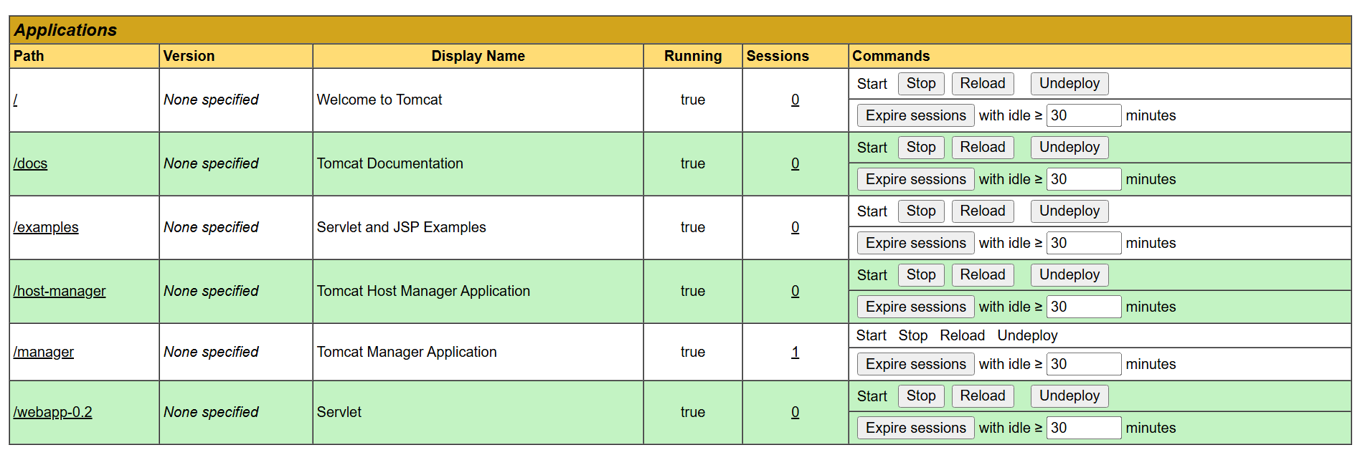

**Now Click ON /webapp-0.2 it will display the Final Output of the Project:**

